**How to enter breakouts**Execution and entries are the most important part of trading, and we want to do everything in our power to make this process repeatable and simple  
  
With my entry models you can enter any breakout with a ton of confidence because you are only looking for a few confluences  
  
The reason why we have such high confidence is because we picked the best setups in the markets, now all we have to do is execute on confirmation  
  
**Entry models**  
  
I have identified 3 super high probability entry models, and ill be going over all three in this document   
  
The first one is the most simple and is simply a buy on break above trigger with volume  
  
Second is a retest trade, that waits for price to retest the trigger (more difficult to execute)  
  
Last one is a daily breakout confirmation entry model, this one is super easy to trade but sometimes will miss moves  
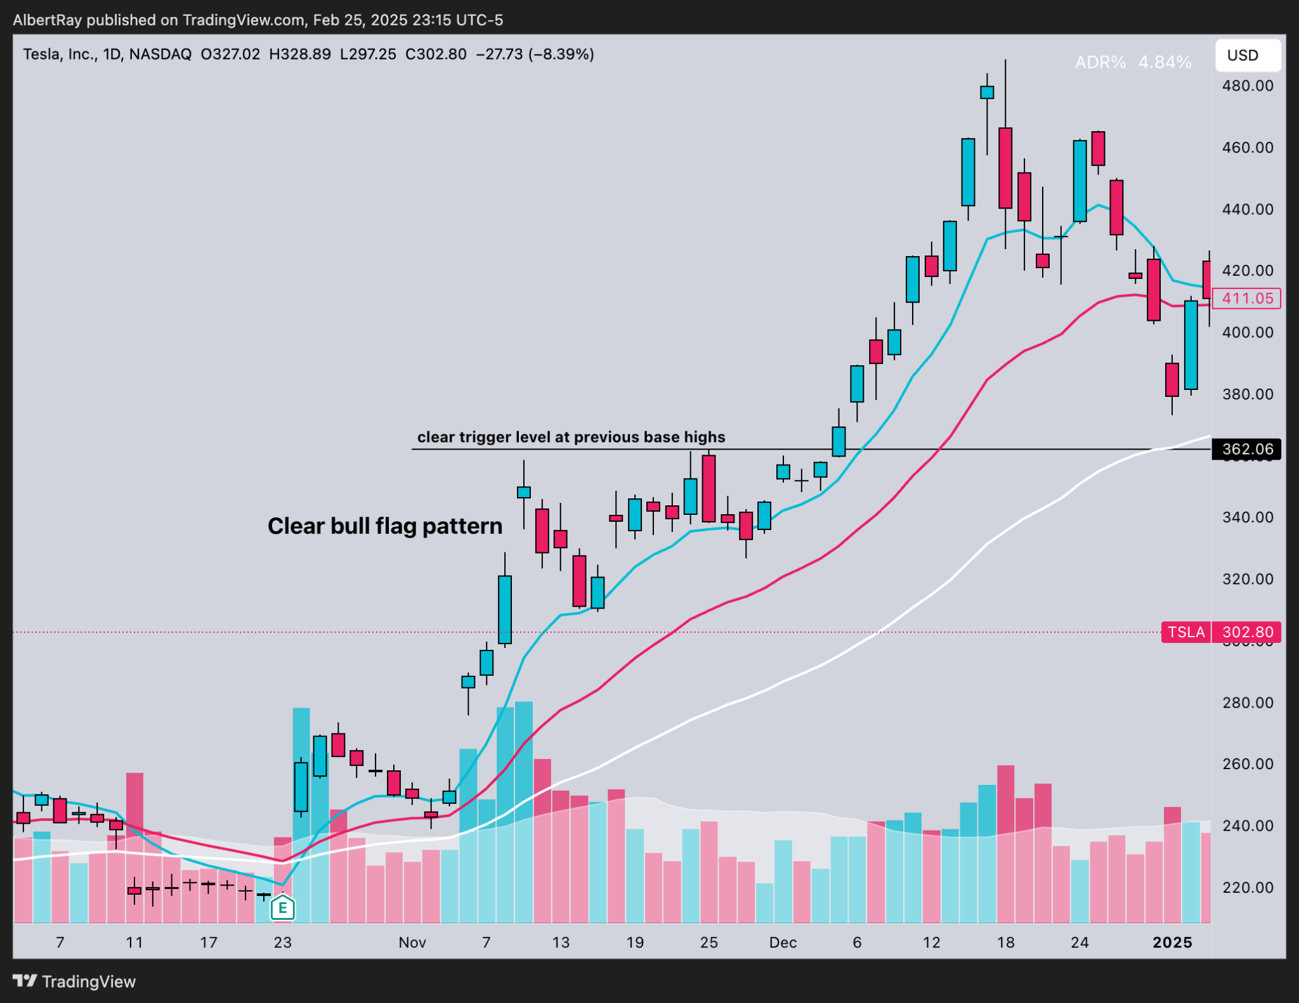  
  
Setup needs to have a clear trigger level like shown above with a tight consolidation pattern  
  
**Entry model #1**   
  
Buying during the breakout   
  
Buying at the time of the breakout guarantees that there is indeed an effective breakout. More momentum and higher volume are early signals that buyers are interested. This increases the chances of a successful breakout a lot more than if you try to anticipate a breakout  
  
If the markets are in a strong uptrend and momentum is strong buy stocks on a break above the trigger level   
  
volume should be 1.5x higher than average indicating aggression   
  
if the markets are choppier/below moving averages and momentum is lackluster wait for a   
  
5m or 15m candle close above your trigger level to confirm the breakout   
  
volume should be 1.5x higher than average indicating aggression   
The stock is bought as soon as the price rises above the identified breakout trigger level.   
  
The stop loss can be placed either below the low of day or previous days low to manage our risk  
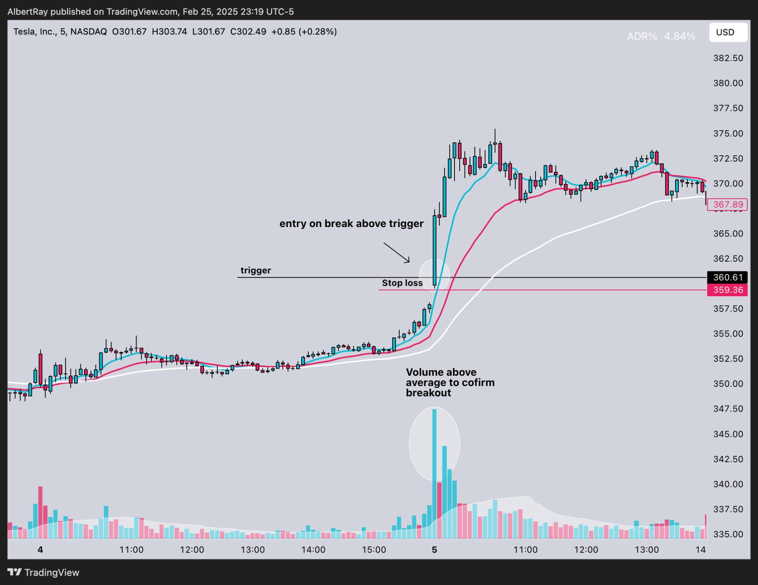  
  
The reason this is the best entry model is because the best breakouts in the market will never come back down to retest the entry spot  
  
This is what's called a lock out rally and usually the streets are caught off guard on this type of move  
  
This will bring in a ton of momentum as people end up chasing the stock much higher later on  
  
  
  
  
  
  
**Entry model #2**  
  
Buying The Retest Of The Breakout  
  
Entry model #2 is mainly used for catching breakouts we missed the first time  
We can also use this entry model if price gaps above our trigger level… this keeps us from chasing price when it's too extended and gives us the best risk to reward  
  
For the retest entry model, we want to look for a big breakout on high volume out of a base… exactly like for entry model #1  
  
The only difference for this entry is we wait for price to come back down and test the trigger level again  
  
After the retest occurs we don't just blindly get into the position   
  
We are looking for 3 things to confirm:  
  
-High volume out of retest of key level  
-Hammer or bullish engulfing candle  
-Tight pattern to form (wedge, bullflag,pennant)  
  
What this does is confirm to us that buyers are still in control and the trend is going to remain intact   
  
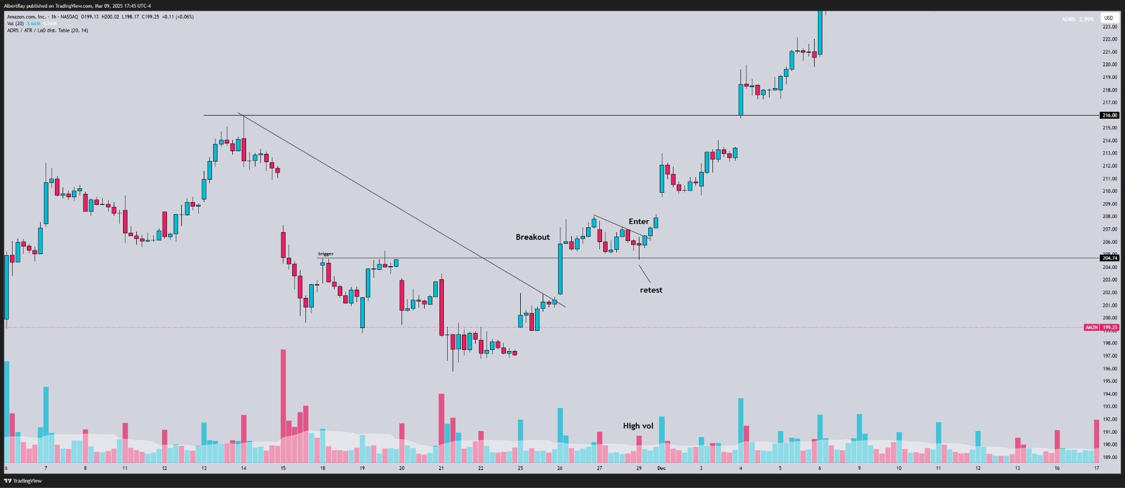  
  
Once we identified these 3 things for our retest we take our entry and stop is placed under the candle that retested the trigger level   
  
This creates for an amazing risk/reward trade  
  
  
  
  
  
**Entry model #3**  
daily breakout confirmation  
  
This entry model has the highest win % the only downfall is you are likely to miss some of the breakout move  
  
I utilize this entry model for longer term swings  
  
The key is to find a big daily level that price has not been able to close above  
  
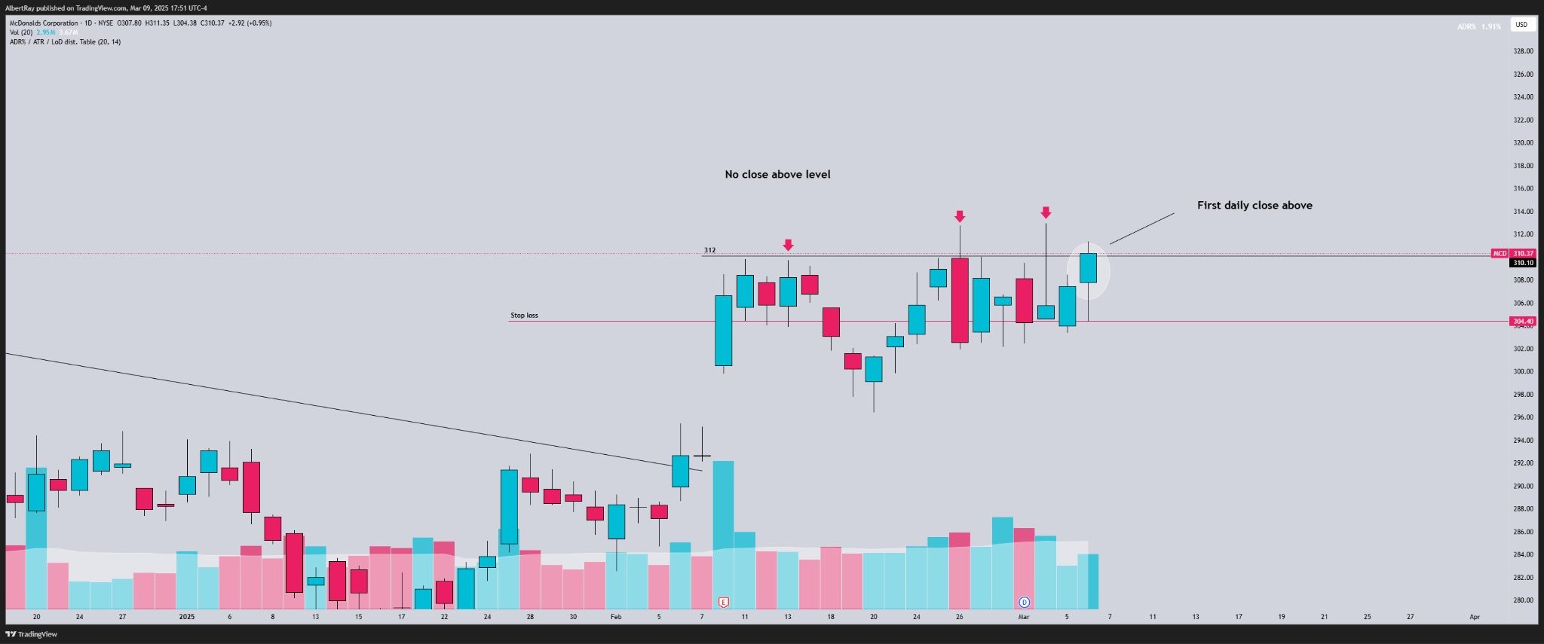  
  
You then have to wait for the daily candle to close above this big daily level   
  
Once this occurs you can take entry into the last 10 minutes of the day, setting your stop loss at the days low  
  
This sets up for a super high probability long setup as continuation is very likely following the breakout  
  
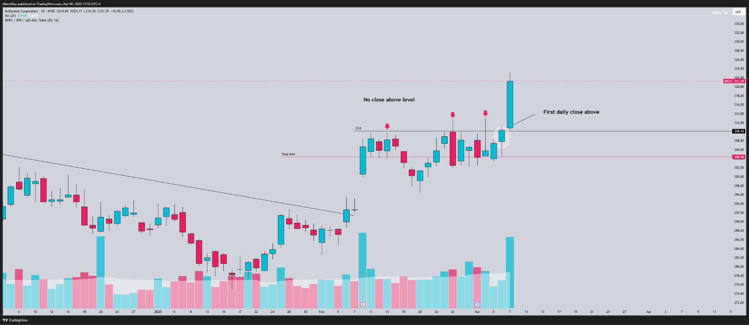  
  
**Downside entries:**When trading short or buying puts entries can be taken the exact same way  
  
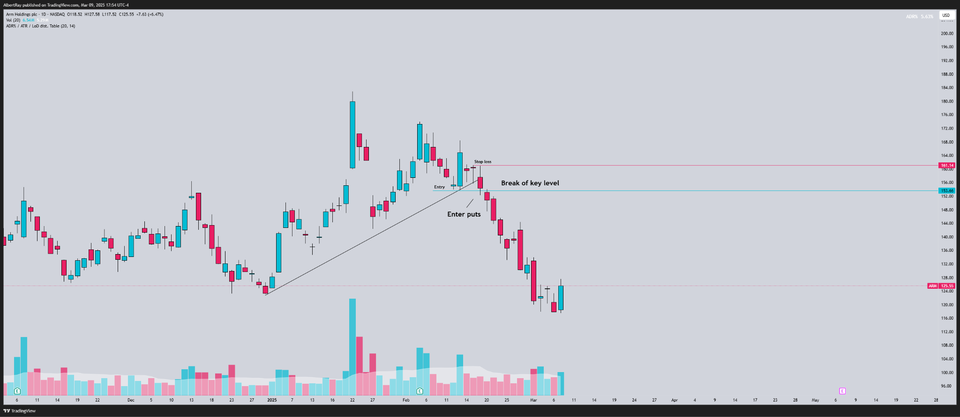  
  
The biggest takeaway is using volume for entries  
  
Volume will confirm the aggression of the key level break and tell you how the stock reacts to the key level  
  
A big breakout or breakdown requires a ton of volume